Lab_5

Eric Huber

02/03/2022

### Question 1:

# a  
d5 = d5[,2]  
  
  
#b  
min(d5)

## [1] 40.88721

max(d5)

## [1] 61.65908

#c  
floor(min(d5))

## [1] 40

ceiling(max(d5))

## [1] 62

bks = seq(40, 62, by = 2)  
  
#d  
hist(d5, main="Frequency of Values",  
 xlab = "Values", breaks = bks, col="blue", border = "black")

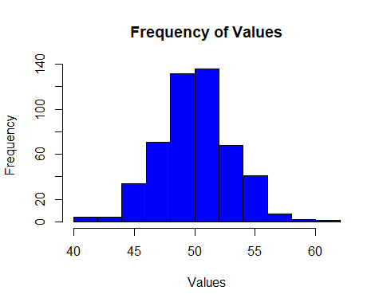

## Questoin 2:

# (2.a)  
hist(d5, main="Frequency of Values",  
 xlab = "Values", breaks = bks, col="blue", border = "black", prob = TRUE)  
  
lines(density(d5), col = "red")

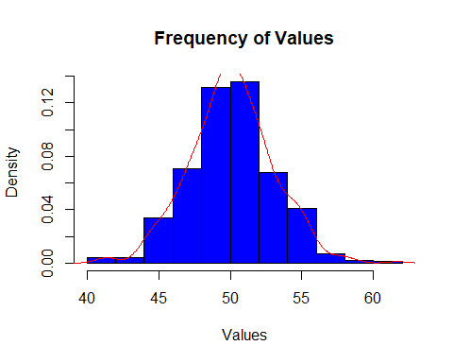

mean(d5)

## [1] 50.096

median(d5)

## [1] 50.09486

Yes! This histogram seems largely normally distributed, we can see that the curve is largely symmetric and bell shaped with most of our values towards the center. We also see that both the mean and median are in the center of the curve.

#(2.b)  
qlow = quantile(d5, 0.025)  
qhigh = quantile(d5, 0.975)  
  
qlow

## 2.5%   
## 44.37995

qhigh

## 97.5%   
## 55.59352

#(2.c)  
μ = mean(d5)  
std = sd(d5)  
  
(μ - (2*std))

## [1] 44.24484

(μ + (2*std))

## [1] 55.94717

1. Question ‘c’ is terribly worded but Steve says this is how we should solve this. This question does not make sense as written.